# 

# SFCC Dispatch Cartridge Installation Guide

23.7.0

## Table Of Contents

Table Of Contents 2

1. Summary 3

2. Component Overview 3

2.1 Supported Features 3

2.1.1 Sync Setting 3

2.1.2 Payment Hook 3

2.1.3 Download Settings 4

2.1.4 Test Connection 4

2.2 Limitations and Constrains 4

2.3 Compatibility 4

2.4 Privacy and Payment 4

3. What is SCAPI 4

3.1 Overview 4

3.2 How Is SCAPI used? 4

4. Implementation Guide 5

4.1 Overview 5

4.2 Installation 5

4.2.1 Import metadata archive 5

4.2.2 Add cartridge to cartridge path 5

4.2.3 Dispatch Business Manager module installation 6

4.2.4 Add API Credentials 7

4.3 Configuration 7

4.3.1 Updating Cartridge Custom Site Preference 7

4.3.2 Update Dispatch Settings in Business Manager extension 8

4.3.3 Configuring Dispatch Cartridge for Adyen 9

4.3.4 Configuring Dispatch Cartridge for Stripe 9

4.4 Salesforce Commerce API Settings 10

4.5 Firewall Requirement 10

4.6 Testing 10

5 Operations and Maintenance 11

5.1 Data Storage 11

5.2 HTTP Service Availability 11

5.3 Testing 11

5.4 Support 11

6 User Guide 11

6.1 Roles, Responsibilities 11

6.2 Business Manager 11

6.3 Storefront Functionality 11

7 Known Issues 12

8 Release History 12

# About Dispatch

Dispatch makes content and media shoppable. We enable merchants using Salesforce Commerce Cloud B2C to transform traditionally marketing-only channels into sales channels. It’s a multi-platform “buy now” button that lets customers buy your products at the moment of inspiration.

Install Dispatch and select a product catalog from which you would like to sell products. Your existing marketing content in these channels becomes shoppable with an embedded checkout from Dispatch. Reach new customers and offer a seamless shopping experience across the internet, from discovery to checkout, without managing new commerce logistics.

Your implementation will allow your business to start selling in new channels with Dispatch, while having orders and payments processed through Salesforce Commerce Cloud B2C, just like your ecommerce website.

## Implementation Overview

This implementation guide describes how to integrate **bm_dispatch**, **int_dispatch,** **int_dispatch_sfra** and **int_dispatch_sg** cartridges version 23.7.0 into your SFCC site.

Cartridges includes:

* Dispatch Settings Page
* Functionality to instantly sync settings / catalog with Dispatch
* Payment authorization via SCAPI through Stripe and Adyen
* Download Settings with basic authentication
* Methods for testing

Dispatch uses SCAPI Basket, Order, and Payment API to place an order in your SFCC instance. To get product and catalog data Dispatch uses [SCAPI Admin](https://developer.salesforce.com/docs/commerce/commerce-api/references/about-commerce-api/about.html).

The publishable / client key provided by your payment service provider is used by Dispatch to tokenize and encrypt credit card info using the payment service provider’s tokenization libraries, so Dispatch is at no point handling, storing, or transferring raw credit card data.

Separately, Dispatch will issue you a private and public keypair (**Dispatch API Key** and **Dispatch Account ID**) used to seamlessly sync and test your configuration with Dispatch. Contact [support@dispatch.co](mailto:support@dispatch.co) to obtain these keys when you are ready to test your integration.

## Component Overview

### 2.1 Supported Features

#### 2.1.1 Sync Products

#### Through Dispatch Settings, merchants can select a product catalog to enable Dispatch embedded checkouts for. **Your chosen catalog must be assigned to a site.** Pressing the sync settings button will trigger Dispatch to sync the latest products in your selected catalog as well as your Dispatch Settings. Dispatch also syncs your catalog daily to ensure the latest information is available. You need to provide your Dispatch API Key / AccountId obtained from [support@dispatch.co](mailto:support@dispatch.co) to successfully sync your settings.

#### 2.1.2 Payment Hook

The Dispatch cartridge comes with a hook, custom code, and instructions to enable payments with Stripe or Adyen through SCAPI. This custom code is required as payment processors do not enable payment capture and authorization via SCAPI by default. Dispatch’s custom code offers a secure workaround method supported by payment processor APIs.

#### 2.1.3 Download Settings

Basic authentication secured endpoint that returns return settings. Secured by Dispatch API key.

curl --location 'https://{{REALM_ID}}.commercecloud.salesforce.com/on/demandware.store/Sites-RefArch-Site/en_US/Dispatch-Settings' \

--header 'Content-Type: application/x-www-form-urlencoded' \

--data-urlencode 'dispatchAPIKey={{API_KEY}}

#### 2.1.4 Test Connection

Validate if connection settings are working as expected. ￼

### 2.2 Limitations and Constraints

At this time Dispatch can only be used by merchants who use Stripe or Adyen for payment processing. If you use another payment processor, please contact us at [support@dispatch.co](mailto:support@dispatch.co) to request support for your payment processor.

### 2.3 Compatibility

Tested against SFRA

* SFRA - v6.1.0
* SCAPI - v1
* Compatibility Mode: 22.7
* Stripe Cartridge - v23.3.0
* Adyen Cartridge - v23.2.0

Tested against SiteGenesis

* + SiteGenesis - v105.2.1
* SCAPI - v1
* Compatibility Mode: 22.7
* Stripe Cartridge - v23.3.0
* Adyen Cartridge - v22.2.2

### 2.4 Privacy

* This integration requires access to the following customer data elements: Email Address, Shipping Address, Order Details, Customer Email and Name.
* The only personal data stored by Dispatch is the customer’s email address as an identifier, along with their IP address.
* Dispatch is GDPR Compliant and will comply with data requests made by your business or the data subject.

## 3. What is SCAPI

### 3.1 Overview

The Salesforce Commerce API (SCAPI) is an API that allows other applications to securely access the platform’s resources externally from the platform itself. An API, or Application Programming interface, is the preferred method for two applications to communicate in real-time. Simply stated, an API allows a server to return or accept information that is requested or sent by another application. The calling application can then interpret the received data and present it to the user.

### 3.2 How Is SCAPI used?

The SCAPI interface grants other applications access to Salesforce Commerce Cloud resources such as baskets, customers, orders, and products. While these resources are usually consumed through the client site storefront that customers see, the interface provides access to those resources for other applications to read, create, or update through service calls.

The general information about SCAPI you can find here: [SCAPI documentation](https://developer.salesforce.com/docs/commerce/commerce-api/overview).

## 4. Implementation Guide

### 4.1 Overview

4 cartridges support this integration:

* 1. **int_dispatch** – Base cartridges which include helper methods and services framework code
  2. **int_dispatch_sfra** – Enables Dispatch to connect to SFRA based SFCC merchant store
  3. **int_dispatch_sg** – Enables Dispatch to connect to SiteGenesis based SFCC merchant store
  4. **bm_dispatch** – Business Manager extension that helps you manage your Dispatch integration

### Installation

#### Import metadata archive

1. zip content of metadata folder then upload and import site-import-dispatch.zip from metadata folder. To do so, go to the **Business Manager > Administration > Site Development > Site Import & Export.** Upload archive using Local option in the Upload Archive section. After uploading, choose metadata.zip in the list and click on import button.

**Figure 1. site-import-dispatch.zip archive import**

#### Add cartridge to cartridge path

Add int_dispatch and int_dispatch_sfra (int_dispatch_sg for sitegenesis) into the cartridge path of a target site. To do so, go to **Business Manager > Administration > Sites > Manage Sites > Your Target Site > Settings** and insert in your cartridge record. Click apply.

**Figure 2. storefront cartridge path**

#### Dispatch Business Manager module installation

Add bm_dispatch and int_dispatch into the cartridge path of the Business Manager. To do so, go to **Business Manager > Administration > Sites > Manage Sites > Business Manager Site.**

**Figure 3. Business Manager Cartridge Path**

Grant access to Business Manager module:

a. Go to **Business Manager > Administration > Organization > Roles & Permissions** and select the target role(s) that needs to have access to Dispatch Settings.

b. Select the **Business Manager Modules** tab in the drop-down list on top. You must select your target site as the active context.

c. Scroll to the Dispatch Settings module. Grant access to it by selecting the checkbox and clicking Update.

Once you do this, every Business Manager user with that role can manage Dispatch Settings by selecting **Business Manager > Merchant Tools > Dispatch Plugin > Dispatch Settings. Note: This page will throw an error until you have completed all of 4.2.**

#### Add API Credentials

**Services**:

* **dispatch.http.scapi** – is used for fetching SFCC data via SCAPI
* **dispatch.http.slasauth** – is used for authenticating and fetching access token
* **dispatch.http.service** – is used or calling Dispatch hook
* **dispatch.http.testservice** – is used for calling the Dispatch test settings endpoint

To access service credentials, go to **Business Manager > Administration > Operations > Services > Credentials** (Figure 4.)

**Figure 4. Services**

You need to update credentials (see 4.4 for detailed instructions on how to retrieve short code and create Admin API credentials)

* **DispatchSCAPIHost**

**URL:** *https://<Short Code>.api.commercecloud.salesforce.com*

**User:** *<OrganizationID> (refer to Figure 5)*

* + - * **DispatchOAuth**

**User:** *SCAPI Admin Client ID (User)*

**Pass:** *SCAPI Admin Password (Password)*

For Org short code go to, **Business Manager > Administration > Salesforce Commerce API Settings** and click **Request Short Code** (shown in Figure 5)

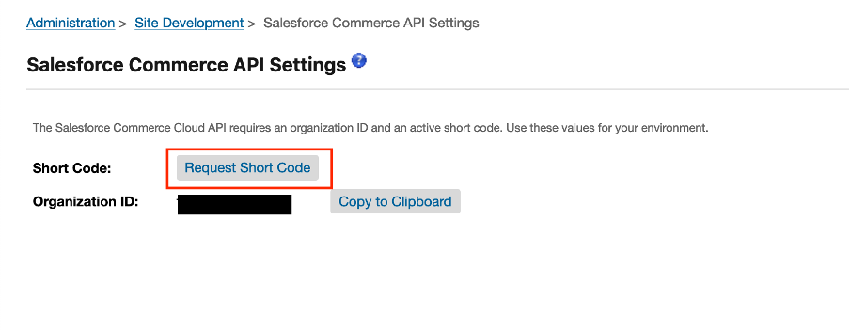

**Figure 5. Short Code**

### Configuration

#### Update Dispatch Settings in Business Manager extension

Go to **Business Manager > Merchant Tools > Dispatch Plugin > Dispatch Settings**

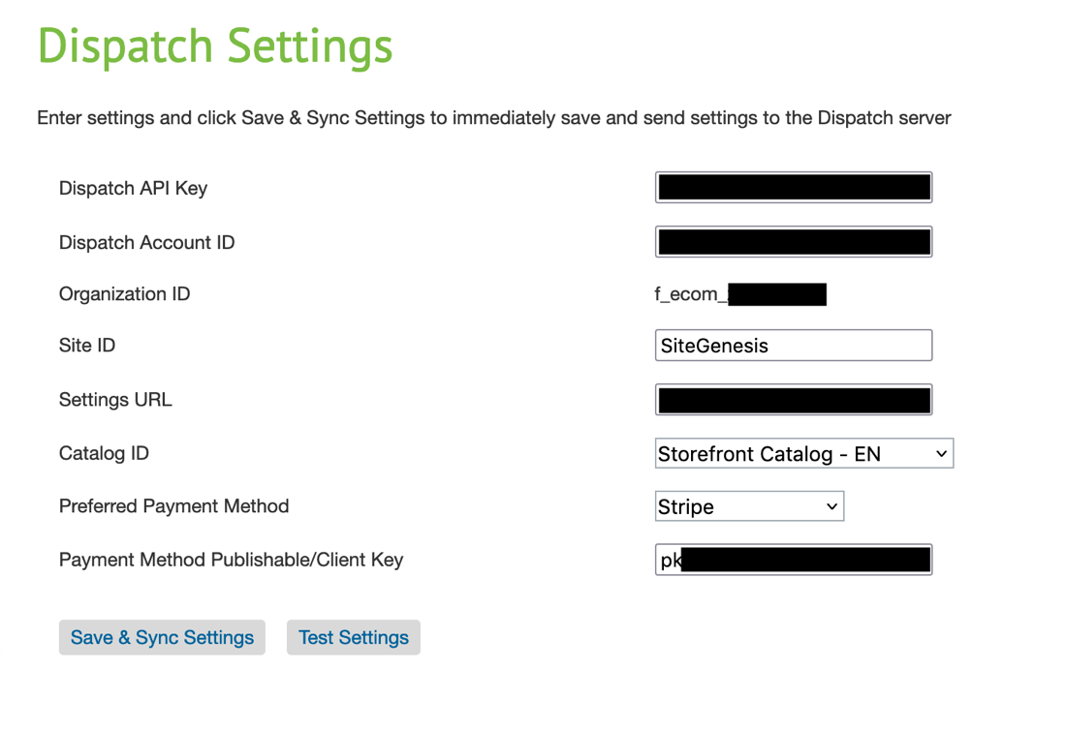

**Figure 6. Dispatch Settings**

* Set **Dispatch AccountID Dispatch API Key** (check Figure 5) **Settings URL** and **Site ID.** You must obtain your Dispatch API Key and Dispatch Account ID from [support@dispatch.co](mailto:support@dispatch.co) . The Settings URL should match the URL on which you configure your Dispatch Settings (example URL: https://${RealmID}-${SandboxID}.dx.commercecloud.salesforce.com/on/demandware.store/Sites-RefArch-Site/en_US/Dispatch-Settings). Note that when configuring for your production / development instances, you *must* use alias values per 2022 Demandware.net Origin Shielding (see [article](https://medium.com/salesforce-commerce-cloud-tales/setup-storefront-hostname-in-salesforce-commerce-cloud-4b4a1732b40b))
* Choose **Preferred Payment Method** and **set Payment Method Publishable/Client Key.** A Dispatch service will pull products from the set Catalog ID and would show Preferred Payment Method to the customer for checkout. **The chosen catalog must be assigned to a site.** Ensure that the preferred payment method is active and fully functional. Click the “Save & Sync Settings” button after completing all required fields. Clicking this button both updates your Settings and kicks off the Catalog Sync job. **All fields must be valid your account can be marked as active, and any changes to those fields resulting in an invalid state will make your account as inactive.**

#### Configuring Dispatch Cartridge for Adyen

Dispatch support for Adyen comes preconfigured just ensure Adyen is fully functional and enabled for SFCC site.

#### Configuring Dispatch Cartridge for Stripe

Dispatch support Stripe but some changes are required. We need to disable authorizeCreditCard hook that comes with Dispatch cartridge and make changes in authorizeCreditCard that comes with Stripe Cartridge.

rename **package.json** to **package-backup.json** located under **link_dispatch > cartridges > int_dispatch**, This will ensure that authorizeCreditCard hook that comes with Dispatch cartridge is disabled.

Next, we are going to make changes in the Stripe cartridge. To do so, open **authorizeCSC.js** located under **int_stripe_core > cartridge > scripts > hooks.** Select from line 62 to 84 (shown in Figure 7) and replace with the following code. (See [Full Ex ample](https://github.com/iex-xyz/dispatch-sfcc-b2c-cartridge/blob/main/documentation/examples/stripe-sample-authorizeCSC.js))

*//*

*// Dispatch specific code.*

*//*

var paymentMethod = stripe.paymentMethods.create({

type: 'card',

card: {

token: paymentInstrument.creditCardToken

},

billing_details: billingDetails

});

var paymentIntent = stripe.paymentIntents.create({

amount: orderAmount,

currency: amount.currencyCode.toLowerCase(),

payment_method: paymentMethod.id,

description: 'Dispatch transaction',

metadata: {

order_id: order.orderNo,

site_id: Site.getCurrent().getID(),

source: "Dispatch - SFCC - Stripe Cartridge"

},

confirm: true

});

**Figure 7. authorizeCSC.js**

You also need to edit each “error” block, so Dispatch’s backend is notified when a payment instantly fails.

if (

paymentIntent.status === 'succeeded'

|| (paymentIntent.status === 'requires_capture' && !stripeChargeCapture)

) {

Transaction.wrap(function () {

if (paymentIntent.id) {

paymentInstrument

.getPaymentTransaction()

.setTransactionID(paymentIntent.id);

}

if (paymentIntent.status === 'succeeded') {

order.setPaymentStatus(Order.PAYMENT_STATUS_PAID);

paymentInstrument

.getPaymentTransaction()

.setType(PaymentTransaction.TYPE_CAPTURE);

} else {

paymentInstrument

.getPaymentTransaction()

.setType(PaymentTransaction.TYPE_AUTH);

}

});

} else {

order.custom.Dispatch_paymentErrorMessage = 'Transaction authorization was not successful';

throw new Error('Transaction authorization was not successful');

}

} catch (e) {

var m = e.message;

if (e.callResult) {

var o = JSON.parse(e.callResult.errorMessage);

m = o.error.message;

}

Logger.error('Error: {0}', e.message);

order.custom.Dispatch_paymentErrorMessage = 'Transaction authorization was not successful';

return new Status(Status.ERROR, m);

}

Be sure you have Stripe Webhooks properly configured per <https://github.com/stripe/stripe-sfcc-b2c-connector/tree/master/documentation>

### 4.4 Salesforce Commerce API Settings

**Setup API Client for SCAPI Admin API access**

Dispatch’s service requires access to SCAPI Admin credentials. Create API client with the following allowed scopes in the [Account Manager](https://account.demandware.com/).

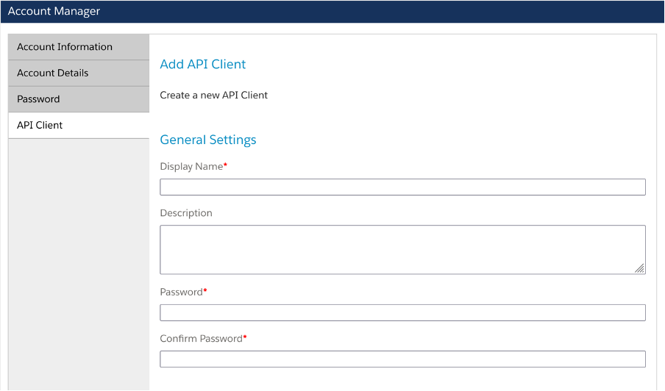

**Figure 8. Account Manager**

**Roles**

Sandbox API User -> All desired instances selected

Salesforce Commerce API -> All desired instances selected

**Default Scopes**

mail

roles

tenantFilter

profile

openId

**Allowed Scopes**

sfcc.catalogs.rw

sfcc.catalogs

sfcc.products.rw

sfcc.products

sfcc.shopper-products

sfcc.orders

Auth Method: client_secret_post

For more information on how to create API client for SCAPI Admin API [check documentation](https://developer.salesforce.com/docs/commerce/commerce-api/guide/authorization-for-admin-apis.html)

**Setup API Client for SCAPI Shopper API access**

* Use the same API Client ID created for SCAPI Admin API and grant Shopper API permissions to it. Copy **API** **Client ID** we created in Account Manager for SCAPI Admin. If it is not the same Client ID for both SCAPI Admin and Shopper APIs, the integration will not work.
* Open https://<Short Code>.api.commercecloud.salesforce.com/shopper/auth-admin/v1/ui/ go to **Clients > Add New Client**
* After adding new client, edit and add **Redirect URI** and add https://**${RealmID}**-**${SandboxID}**.dx.commercecloud.salesforce.com/on/demandware.store/Sites-RefArch-Site/default/Dispatch-SLASRetriveCode

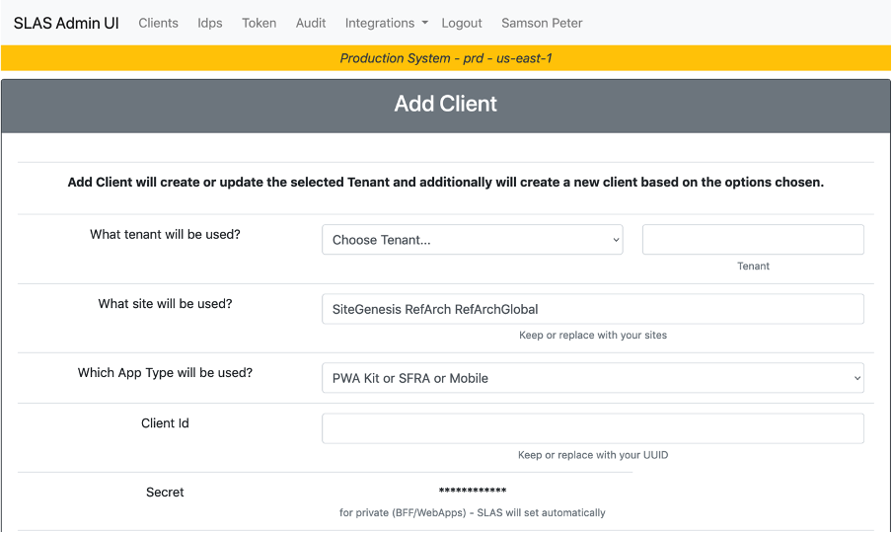

**Figure 10. SLAS Admin UI**

For more information on how to create Client for Shopper API [check documentation](https://developer.salesforce.com/docs/commerce/commerce-api/guide/authorization-for-shopper-apis.html)

### 4.6 Testing

* Dispatch can provide you a sandbox for testing purposes. Please contact Dispatch at [support@disptach.co](mailto:support@disptach.co) for access
* To test services credentials, and Dispatch API Key. Go to **Business Manager > Merchant Tools > Dispatch Plugin > Dispatch Settings**

**Figure 11. TestConnection**

“Test Settings” will run 2 tests.

1) Dispatch Settings Test. Checks if Dispatch Server can download settings and pull catalog data.

2) Dispatch SLAS Shopper Login Test. Checks if Dispatch can login as a guest shopper

## 

## Operations and Maintenance

## HTTP Service Availability

You can track availability and downtime by service status in the Commerce Cloud Business Manager. Go to **Administration > Operations > Service Status > dispatch.http.service**

### Support

If you require assistance on integration or with anything else, please contact us at [support@dispatch.co](mailto:support@dispatch.co)

### Billing

Dispatch invoices your business monthly for commission fees earned during the billing period. Invoices are issued 14 days after the billing period. Commission fees are calculated as a % fee of the GMV generated through the Dispatch SDK. Commission fees are only collected for qualified orders. For an order to be qualified, the payment must be successful. Dispatch will exclude any orders that have been refunded or cancelled.

## User Guide

### 6.1 Roles and Responsibilities

### Refer to Business Manager extension setup instructions.

### 6.2 Business Manager

Refer to installation instructions.

## Release History

|  |  |  |
| --- | --- | --- |
| **Version** | **Date** | **Changes** |
| 23.7.0 | 2023.08.14 | Initial release |